How to use the image processing pipeline in its final application

In FINAL_APP:
- make sure all required files and folders are present

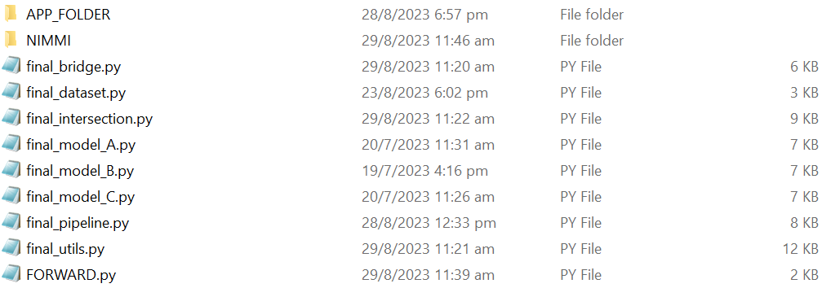

In APP_FOLDER:
- store the checkpoint files of the three DL models and specify them in the FORWARD.py file
- The pretrained models can be downloaded from Hugging Face: https://huggingface.co/yeshekway/lower-limb-muscle-segmentation
- Note that
  - model A refers to lower-limb-muscle-and-sat-segmentation.pth
  - model B refers to thigh-muscle-segmentation.pth
  - model C refers to calf-muscle-segmentation.pth

In FORWARD.py:
- specify which of the models should be applied on the MRI data stored in the SOURCE_FOLDER and if the MAT and the Inter- and IntraMAT will be quantified consecutively
- initialize the checkpoint file names stored in the APP_FOLDER
- run the file

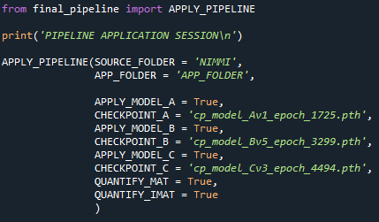

Consider:
  - the SOURCE_FOLDER contains the MRI data in a certain structure e.g., COHORT/SUBJECT/VISIT/BODY PART/SCANS, and must be adapted in the get_files functions of _final_utils.py, _final_bridge.py and _final_intersection.py, in case the data is stored in a different structure
  - the sequence of datapoints needs to be characterized by successive alternating calf and thigh, starting with calf (e.g. CALF, THIGH, CALF, THIGH, ...) through all subjects and visits

